L1, L2 Lasso Ridge elastic

Regularizers

2 techiniques to deal with overfitting and underfitting

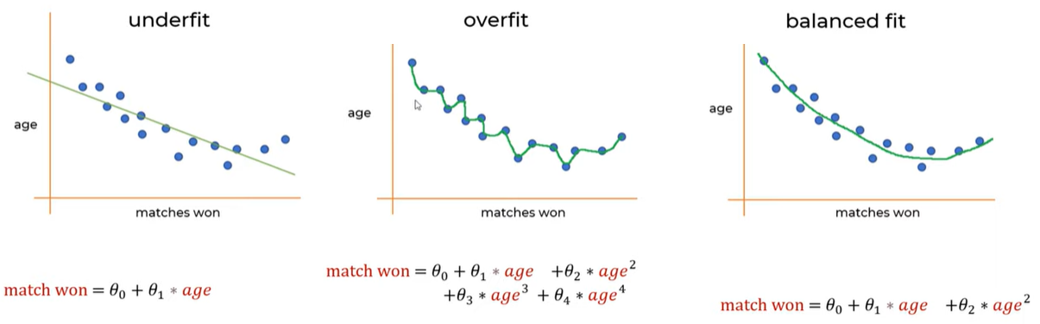

import numpy as np

import matplotlib.pyplot as plt

import pandas as pd

import seaborn as sns

import warnings

warnings.filterwarnings('ignore')

dataset = pd.read_csv('MELBOURNE_HOUSE_PRICES_LESS.csv')

dataset.head(5)

dataset.columns

dataset = dataset.head(10000)

dataset.nunique()

dataset.isna().sum()

#if empty fill with zero

cols_to_fill_zero=['Propertycount','Distance','Bedroom2','Bathroom','Car']

dataset[cols_to_fill_zero]= dataset[cols_to_fill_zero].fillna(0)

dataset.isna().sum()

dataset['Landsize']     = dataset['Landsize'].fillna(dataset.Landsize.mean())

dataset['BuildingArea'] = dataset['BuildingArea'].fillna(dataset.BuildingArea.mean())

#drop if there is null

dataset.dropna(inplace=True)

dataset['Landsize']     = dataset['Landsize'].fillna(dataset.Landsize.mean())

dataset['BuildingArea'] = dataset['BuildingArea'].fillna(dataset.BuildingArea.mean())

#drop if there is null

dataset.dropna(inplace=True)

dataset =pd.get_dummies(dataset, drop_first=True)

dataset.head()

dataset.dropna(inplace=True)

X = dataset.drop('Price',axis=1)

y = dataset['Price']

from sklearn.model_selection import train_test_split

train_X, test_X, train_y, test_y = train_test_split(X, y, test_size=0.3, random_state=2)

from sklearn.model_selection import train_test_split

train_X, test_X, train_y, test_y = train_test_split(X, y, test_size=0.3, random_state=2)

from sklearn.linear_model import LinearRegression

reg = LinearRegression().fit(train_X, train_y)

reg.score(test_X, test_y)

reg.score(train_X, train_y)

from sklearn import linear_model

lasso_reg = linear_model.Lasso(alpha=50, max_iter=100, tol=0.1)

lasso_reg.fit(train_X, train_y)

lasso_reg.score(test_X, test_y)

lasso_reg.score(train_X, train_y)

from sklearn import linear_model

ridge_reg = linear_model.Ridge(alpha=50, max_iter=100, tol=0.1)

ridge_reg.fit(train_X, train_y)

ridge_reg.score(test_X, test_y)

ridge_reg.score(train_X, train_y)

LASSO

from sklearn import linear_model

lasso_reg = linear_model.Lasso(alpha=50, max_iter=100, tol=0.1)

lasso_reg.fit(train_X, train_y)

lasso_reg.score(test_X, test_y)

lasso_reg.score(train_X, train_y)

RIDGE

from sklearn import linear_model

ridge_reg = linear_model.Ridge(alpha=50, max_iter=100, tol=0.1)

ridge_reg.fit(train_X, train_y)

ridge_reg.score(test_X, test_y)

ridge_reg.score(train_X, train_y)